**INSTALL PILLOW TO USE IMAGE FIELD IN DJANGO MODELS**

IN ORDER TO USE ***ImageField*** IN DJANGO MODELS, WE HAVE TO INSTALL ***Pillow*** FIRST: ***pip install Pillow***

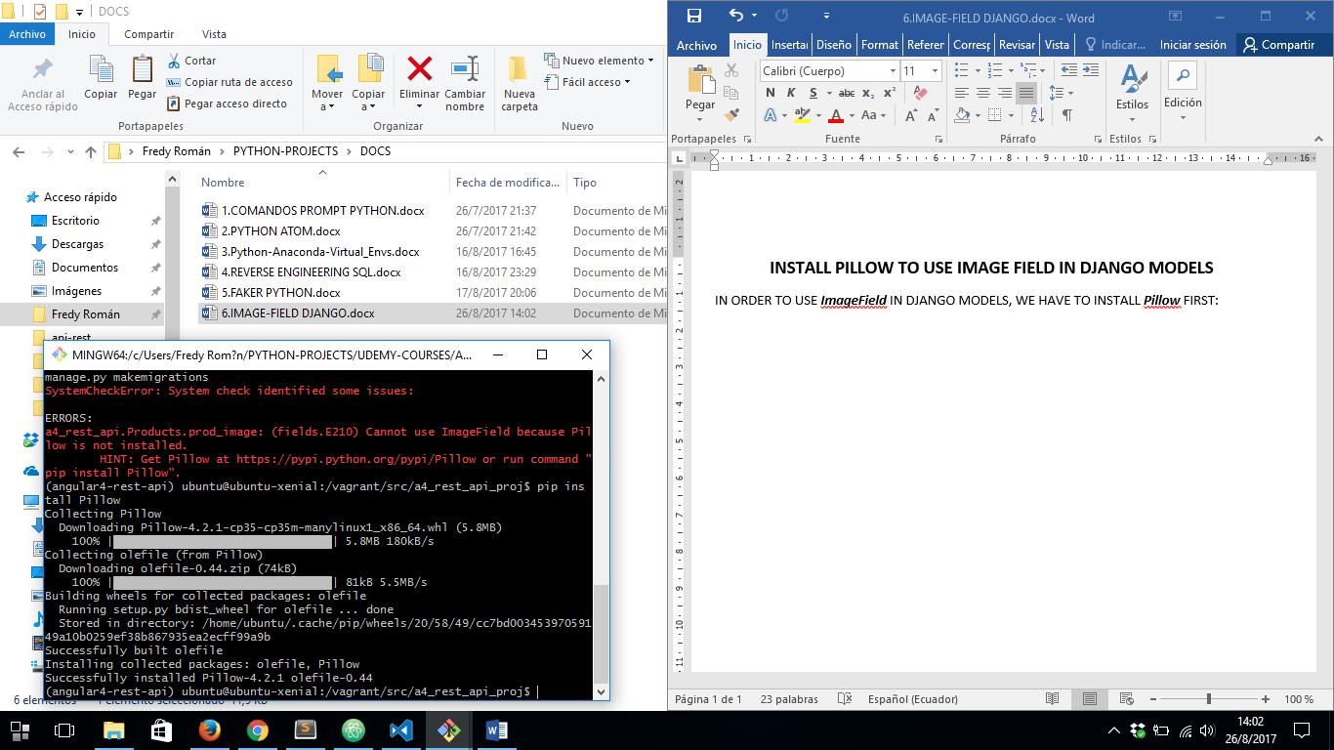

THEN WE’RE ABLE TO RUN ***python manage.py makemigrations*** AND ***python manage.py migrate***

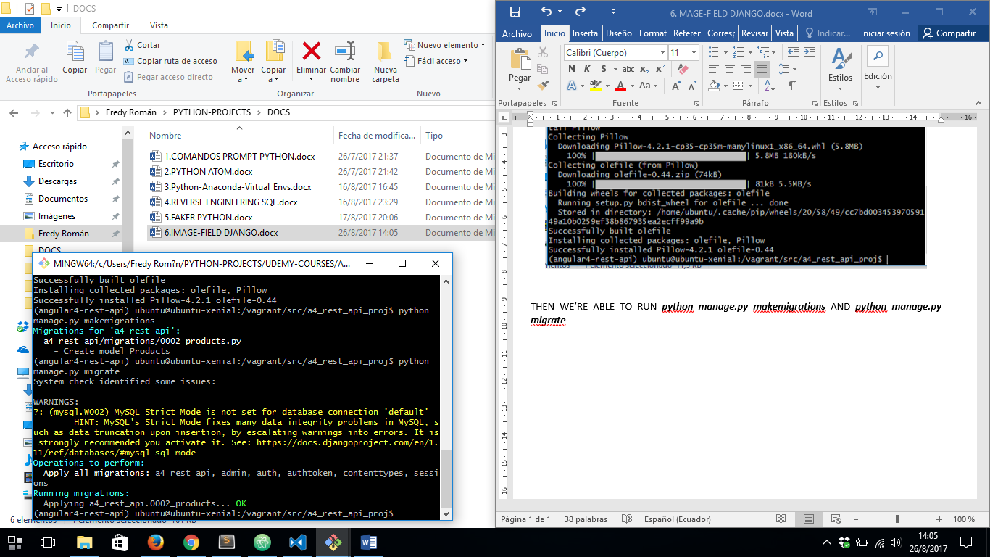

**DJANGO REST FRAMEWORK**

REF: <https://cjh5414.github.io/django-rest-framework-imagefield/>

IF WE WANT TO SAVE AND RETRIEVE IMAGE FILES THROUGH OUR REST API WE MUST DO NEXT:

1. IN ***project/settings.py*** FILE ADD:

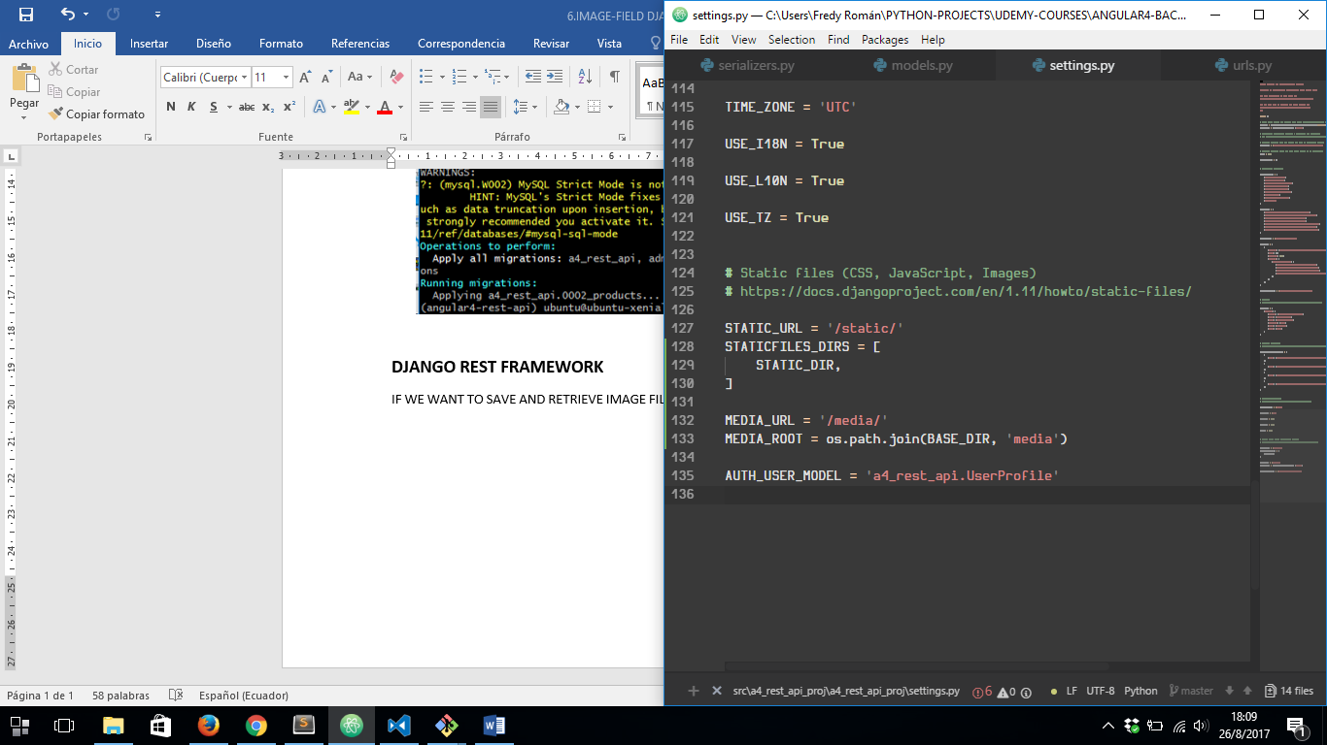

1. IN ***project/urls.py*** FILE ADD:

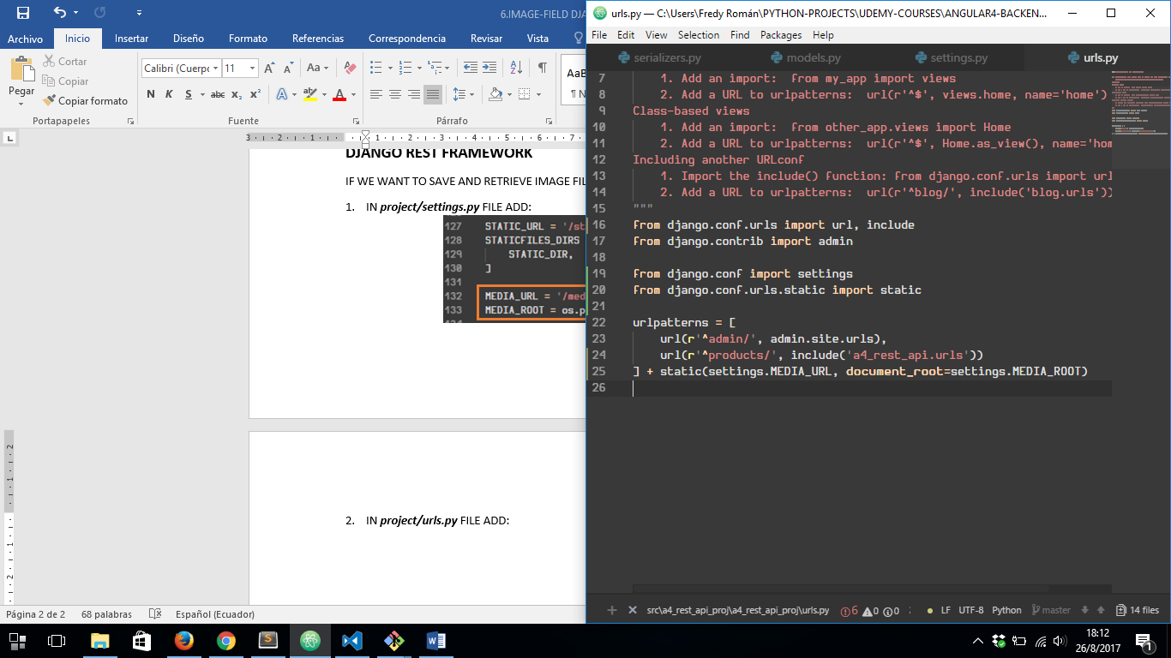

AND AFTER CONFIGURE OUR VIEW AND SERIALIZER ***.PY*** FILES THEN WE COULD SEE OUR FILES ON MEDIA FOLDER: